ClassPolicy Next Teacher App Setup for AD sign in

History
Date | Comment
2019-08-07 | Added “supported account types” when Azure app is created
2019-09-02 | Updated with recent Azure AD GUI
2020-07-15 | Updated to copy & paste App ID into CP admin site’s App ID for Classroom onenote
2021-09-28 | Updated for ClassPolicy Next Teacher app
2021-11-25 | Added UWP app Azure redirect URI

Things you will need
- Admin account to your Office 365 tenancy Azure AD

- Admin account to your ClassPolicy district admin website

Steps
The following pages are a condensed and modified version of the Microsoft document (https://msdn.microsoft.com/office/office365/howto/add-common-consent-manually) with just the information needed to give ClassPolicy app access to Office365 APIs for Class Notebook and Microsoft Teams integration. As processes and documentation constantly change, if you come across discrepancies, please refer to the Microsoft document for a full explanation and complete instructions. Please also notify us of the changes at support@assistx.me so we can update this document to ensure that it is accurate.

Register ClassPolicy Next Teacher AAD app with the Azure Management Portal

The following instructions are for granting ClassPolicy teacher app access to Class Notebooks and Microsoft Teams through ClassPolicy Azure AD app.
- Sign into the Azure Management Portal, using your Office 365 business admin account credentials.
- Click the Azure Active Directory node in the left column and select the directory linked to your Office 365 subscription.
- Select the App registrations tab and then New registration at the top of the page.
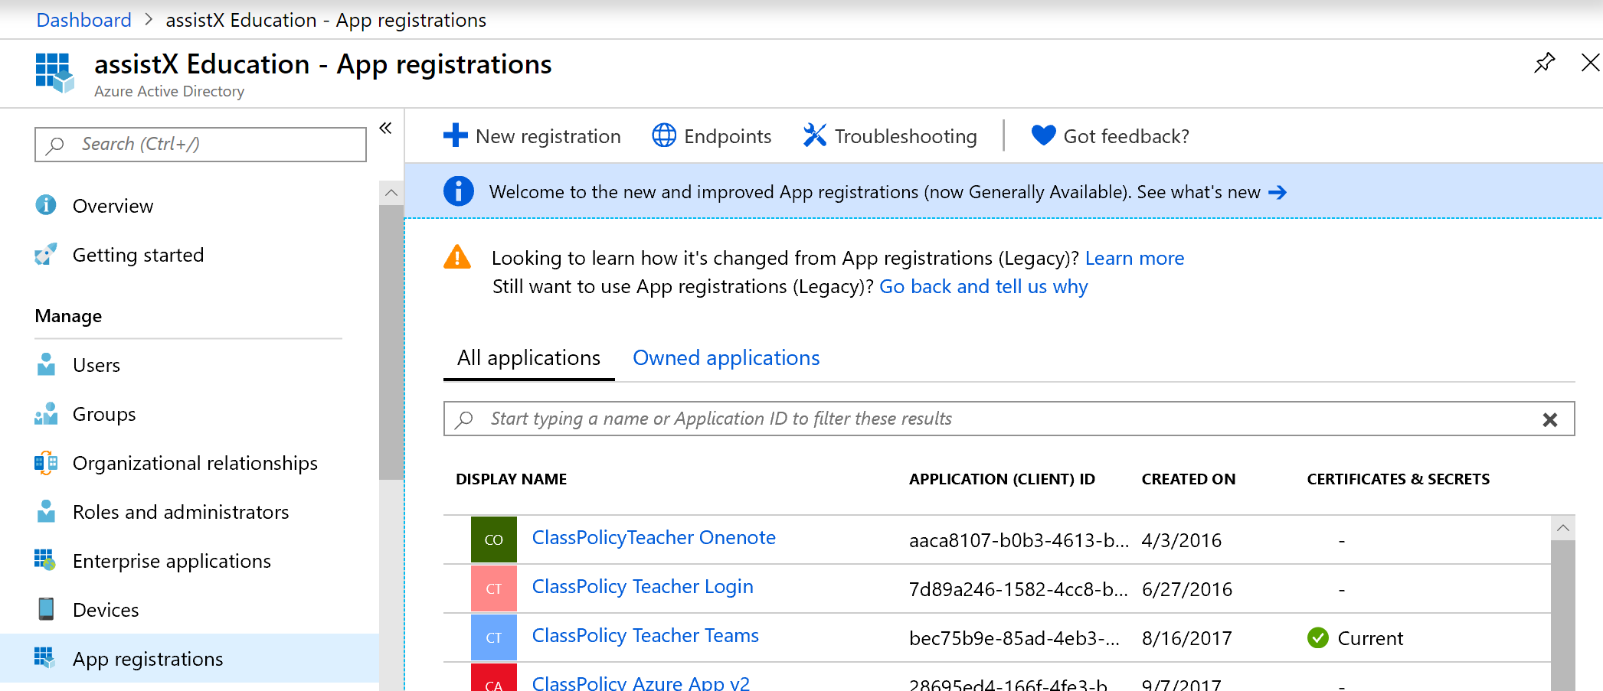
- Enter “ClassPolicy Next Azure App” for the Name for your app and select Native as its Application type. For “Supported account types”, select “Accounts in any organizational directory (Any Azure AD directory – Multitenant).
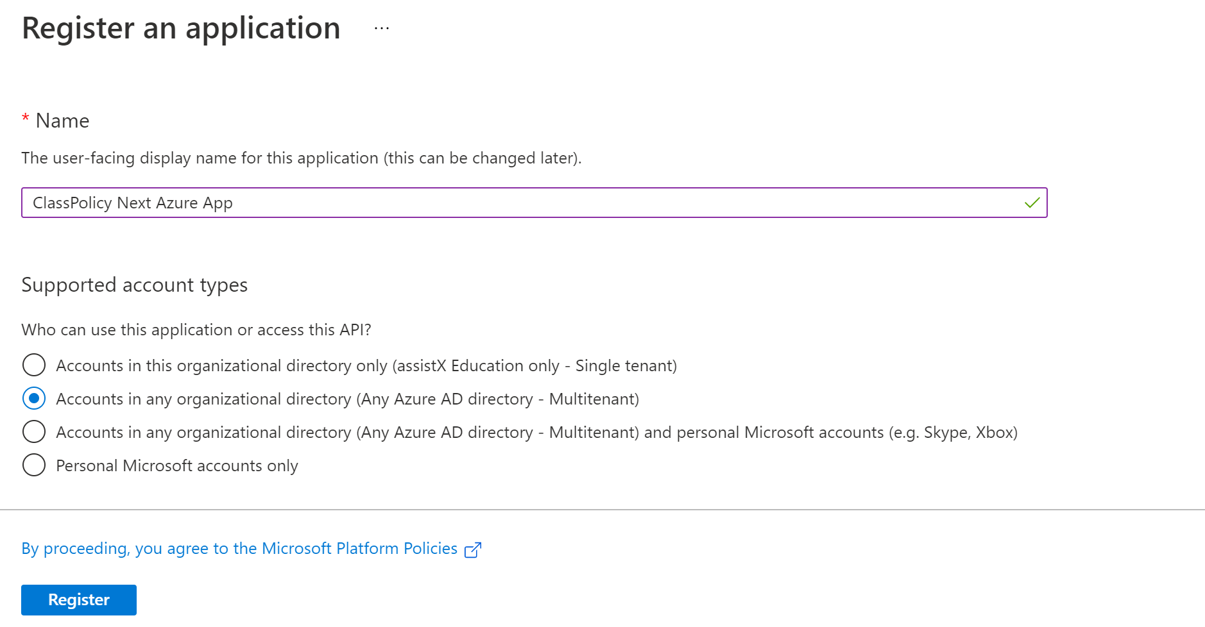
- After the app has been registered successfully, click on Add a Redirect URI. Then + Add a platform. Choose Mobile and desktop applications.
  - For Custom redirect URIs, enter “ms-app://S-1-15-2-835787666-1316706567-2160823966-2447606588-810271630-44976689-2448769214” without “”.
  - Then click Configure.

  - For Custom redirect URIs, enter “ms-appx-web://Microsoft.AAD.BrokerPlugIn/S-1-15-2-835787666-1316706567-2160823966-2447606588-810271630-44976689-2448769214” without “”.
  - Then click Configure/Save.
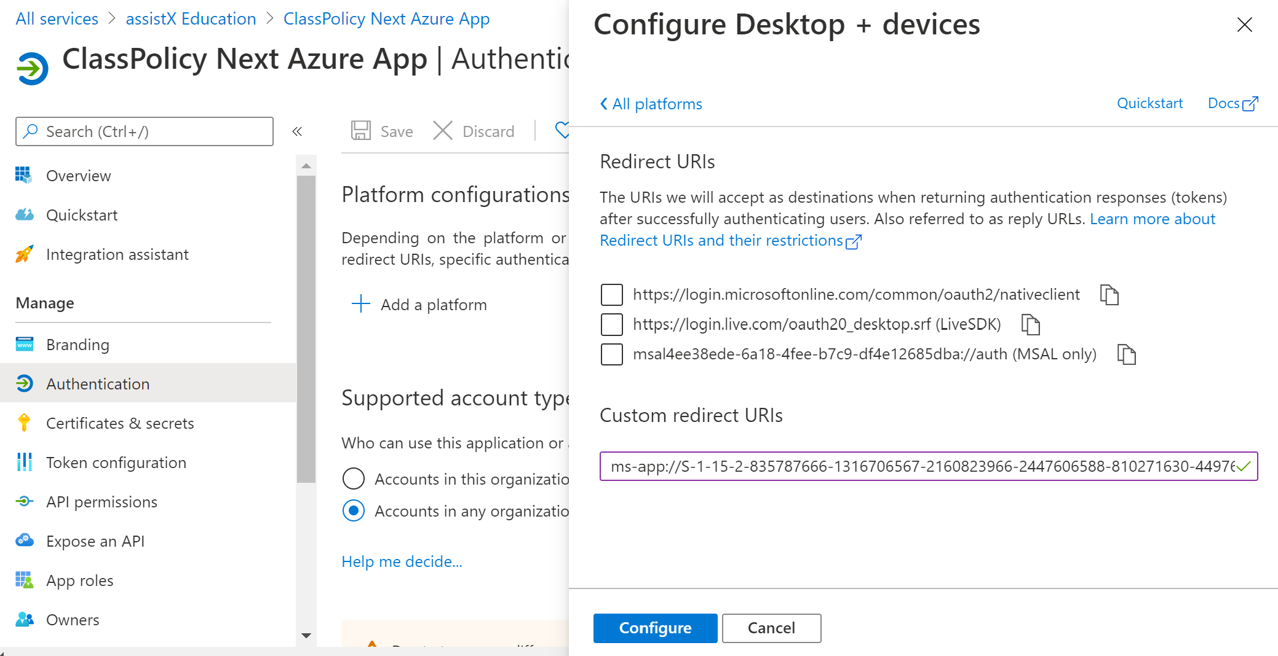

  - If it complains about invalid redirect URI, it might be something to do with copy & paste of the above URI having some invisible control characters. To work around this, open Notepad app, copy & paste into Notepad first, then copy & paste into Redirect URI field again.

- Go to API permissions tab, and click on Grant admin consent for your school.
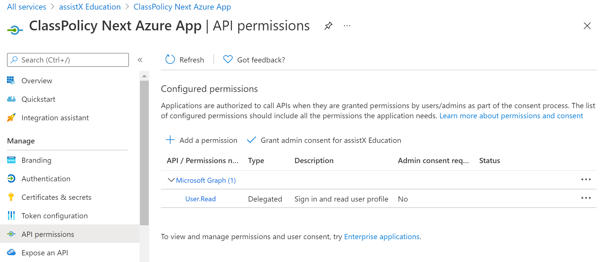
- After granting permissions for your school, your screen should look like the following:
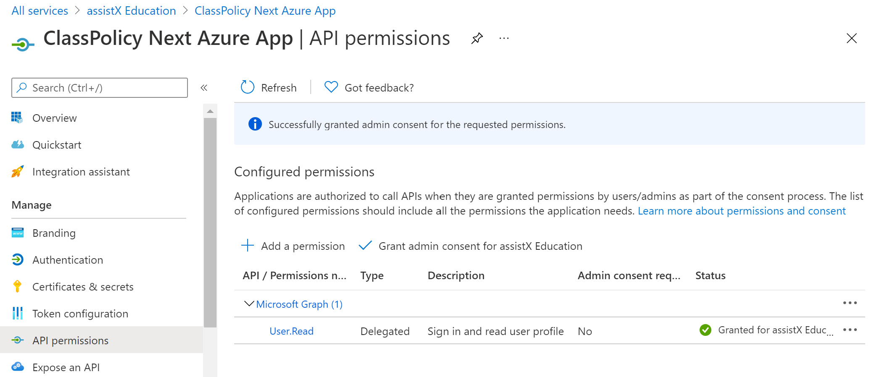

- Click on Overview tab. Your screen should look like the below. Copy Application (client) ID value, which will be used for the next part of registration.
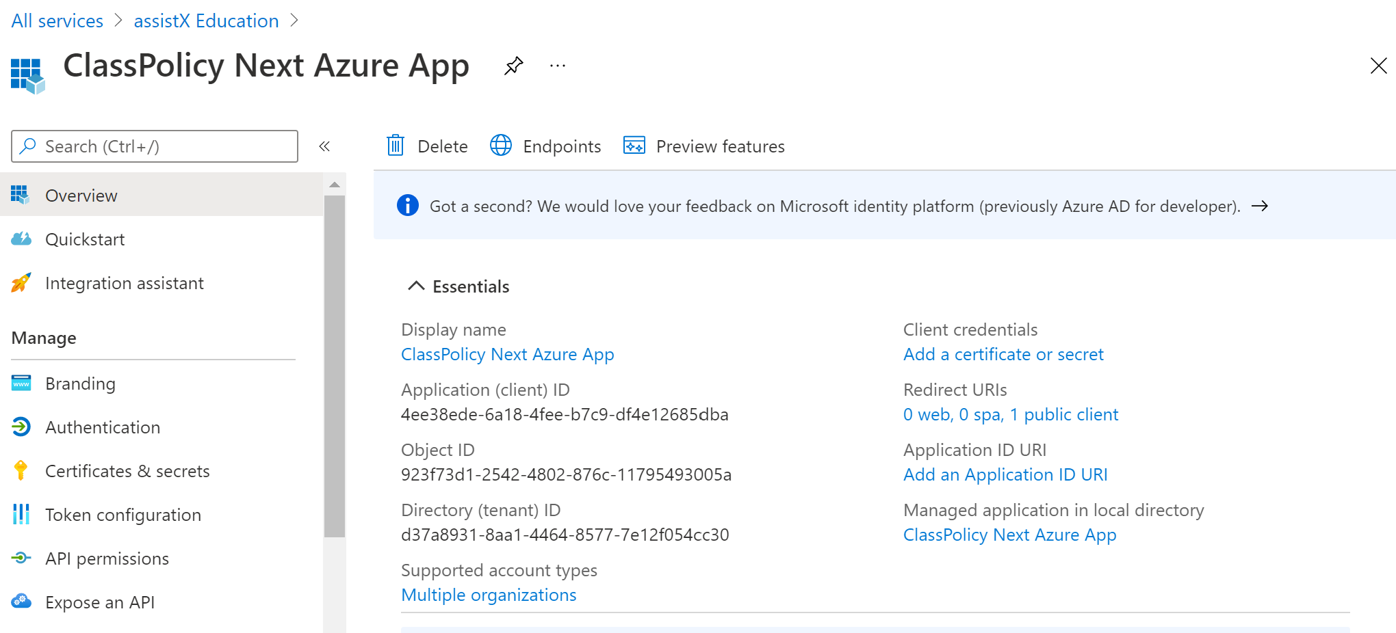

Configure ClassPolicy District Admin Setting

Now that your ClassPolicy Azure app is now registered and configured with necessary permissions. The next step is to configure your ClassPolicy district setting to connect ClassPolicy teacher app to the ClassPolicy Azure app that you have created by following the steps below.

- Login to the ClassPolicy Admin with your administrator credentials.

- From the left navigation select “District” and then “Edit district” as shown in the image below.

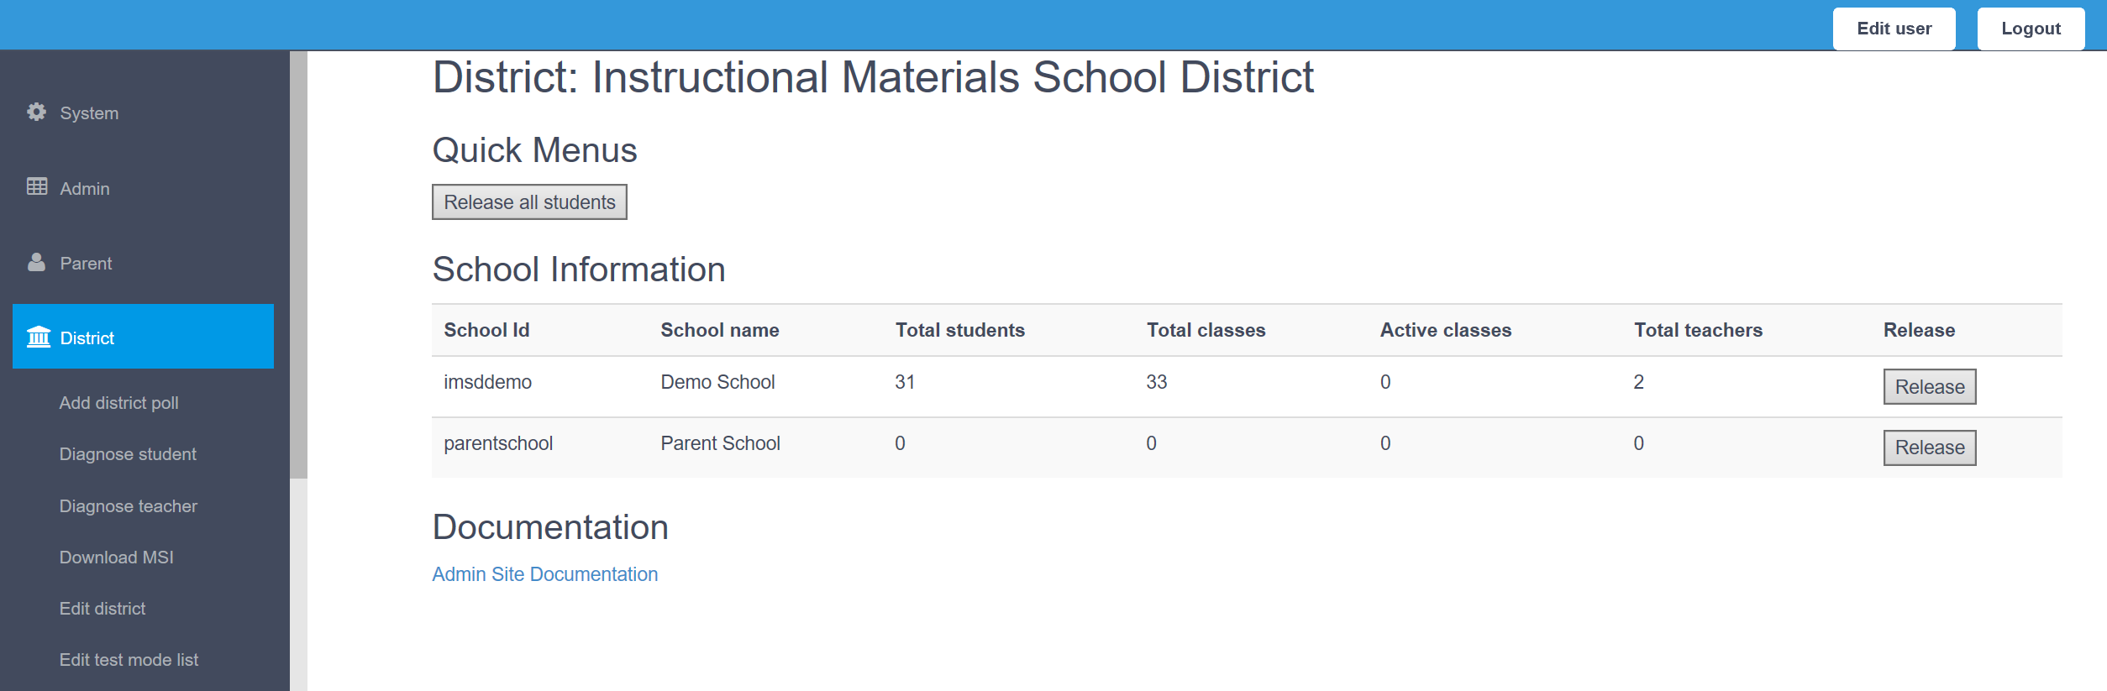

- In the “Domain Suffix” text box, enter the domain suffix of your student’s Office 365 accounts. The suffix should start with an @ symbol added to a domain name.

- Copy Application (client) ID from creating “ClassPolicy Next Azure App” to paste into ClassPolicy admin site’s Edit district’s “ClassPolicy Next Teacher AAD Application ID”.
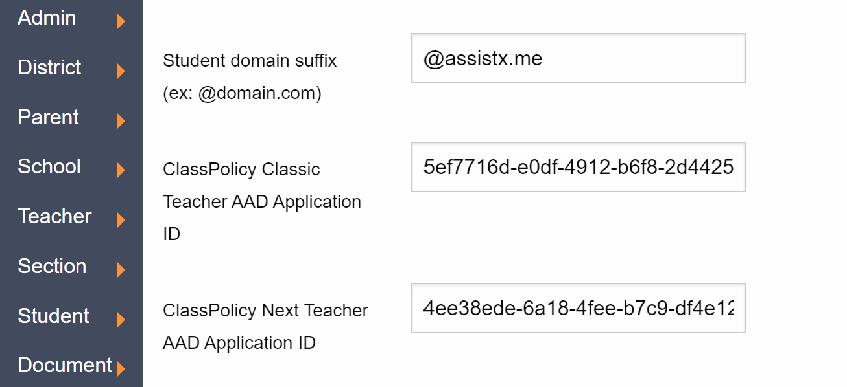

- If you want for teachers to sign in with their Azure AD account, you may change “Teacher sign in method” to “AAD_SIGNIN”.
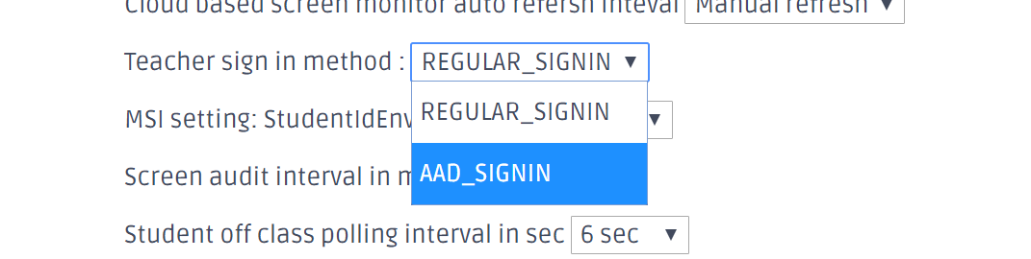
- Scroll down and click on the “Update” button to save changes. The confirmation dialog will pop up as below:
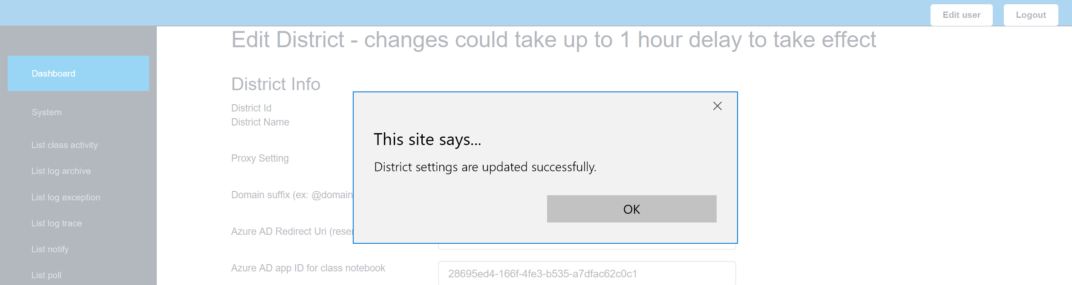

That completes the setup process to enable Class Notebook orchestration with ClassPolicy. If you have any issues, please contact us at support@assistx.me and we will be happy to assist you.

