ClassPolicy Setup for Admin Azure AD Sign- In

Things you will need
- Admin account to your Office 365 tenancy Azure AD

- Admin account to your ClassPolicy district admin website

- Azure AD Admin security groups for the below roles:

  - District level admin security group
  - Helpdesk security group [optional]
  - School level admin security group [optional]

Steps
As processes and documentation constantly change, if you come across discrepancies, please notify us of the changes at support@assistx.me so we can update this document to ensure that it is accurate.

Register ClassPolicy Admin Azure AD app with the Azure Management Portal

The following instructions are for granting ClassPolicy Azure admin app access to user login info.
- Sign into the Azure Management Portal, using your Office 365 business admin account credentials.
- Click the Azure Active Directory node in the left column and select the directory linked to your Office 365 subscription.
- Select the App registrations tab and then New registration at the top of the page.
- From New registration,
  - Enter “ClassPolicy Admin App” for the Name for your app.
  - For “Supported account types”, select “Accounts in any organizational directory (Any Azure AD directory – Multitenant).
  - For “”, select “Web API”. For Redirect URIs, choose one of ClassPolicy redirect URIs from the below table base on your ClassPolicy admin URL.
Your subscription URL | Redirect URI
https://classpolicy1.classpolicy.com | https://classpolicy1.classpolicy.com/account/authorize
https://classpolicy2.classpolicy.com | https://classpolicy2.classpolicy.com/account/authorize
https://classpolicyau1.classpolicy.com | https://classpolicyau1.classpolicy.com/account/authorize
https://classpolicyeurope1.classpolicy.com | https://classpolicyeurope1.classpolicy.com/account/authorize

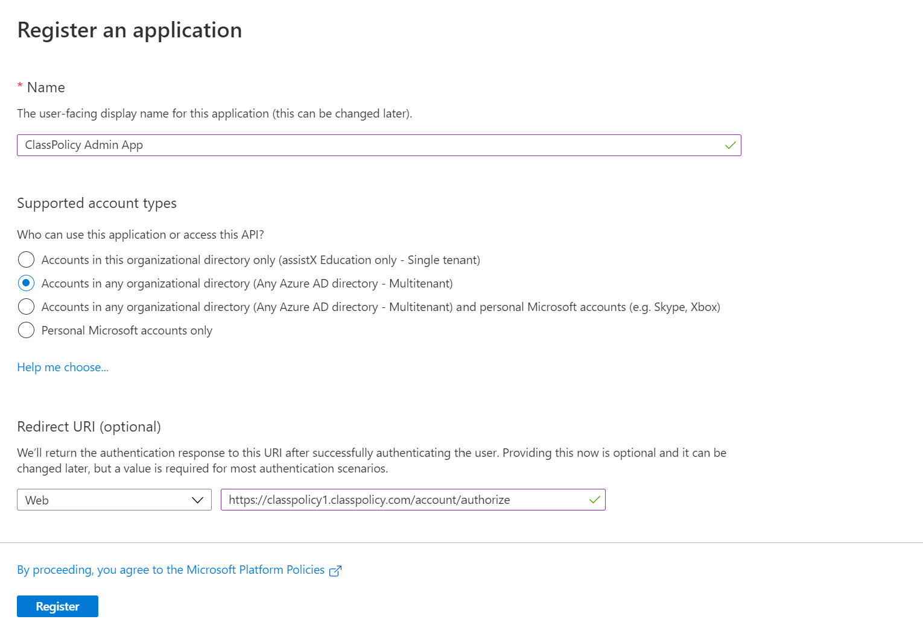
- Then click Register.

- Click the app that you have just registered. Your screen should look like the following. Copy Application (client) ID, which is necessary later for ClassPolicy admin site configuration.
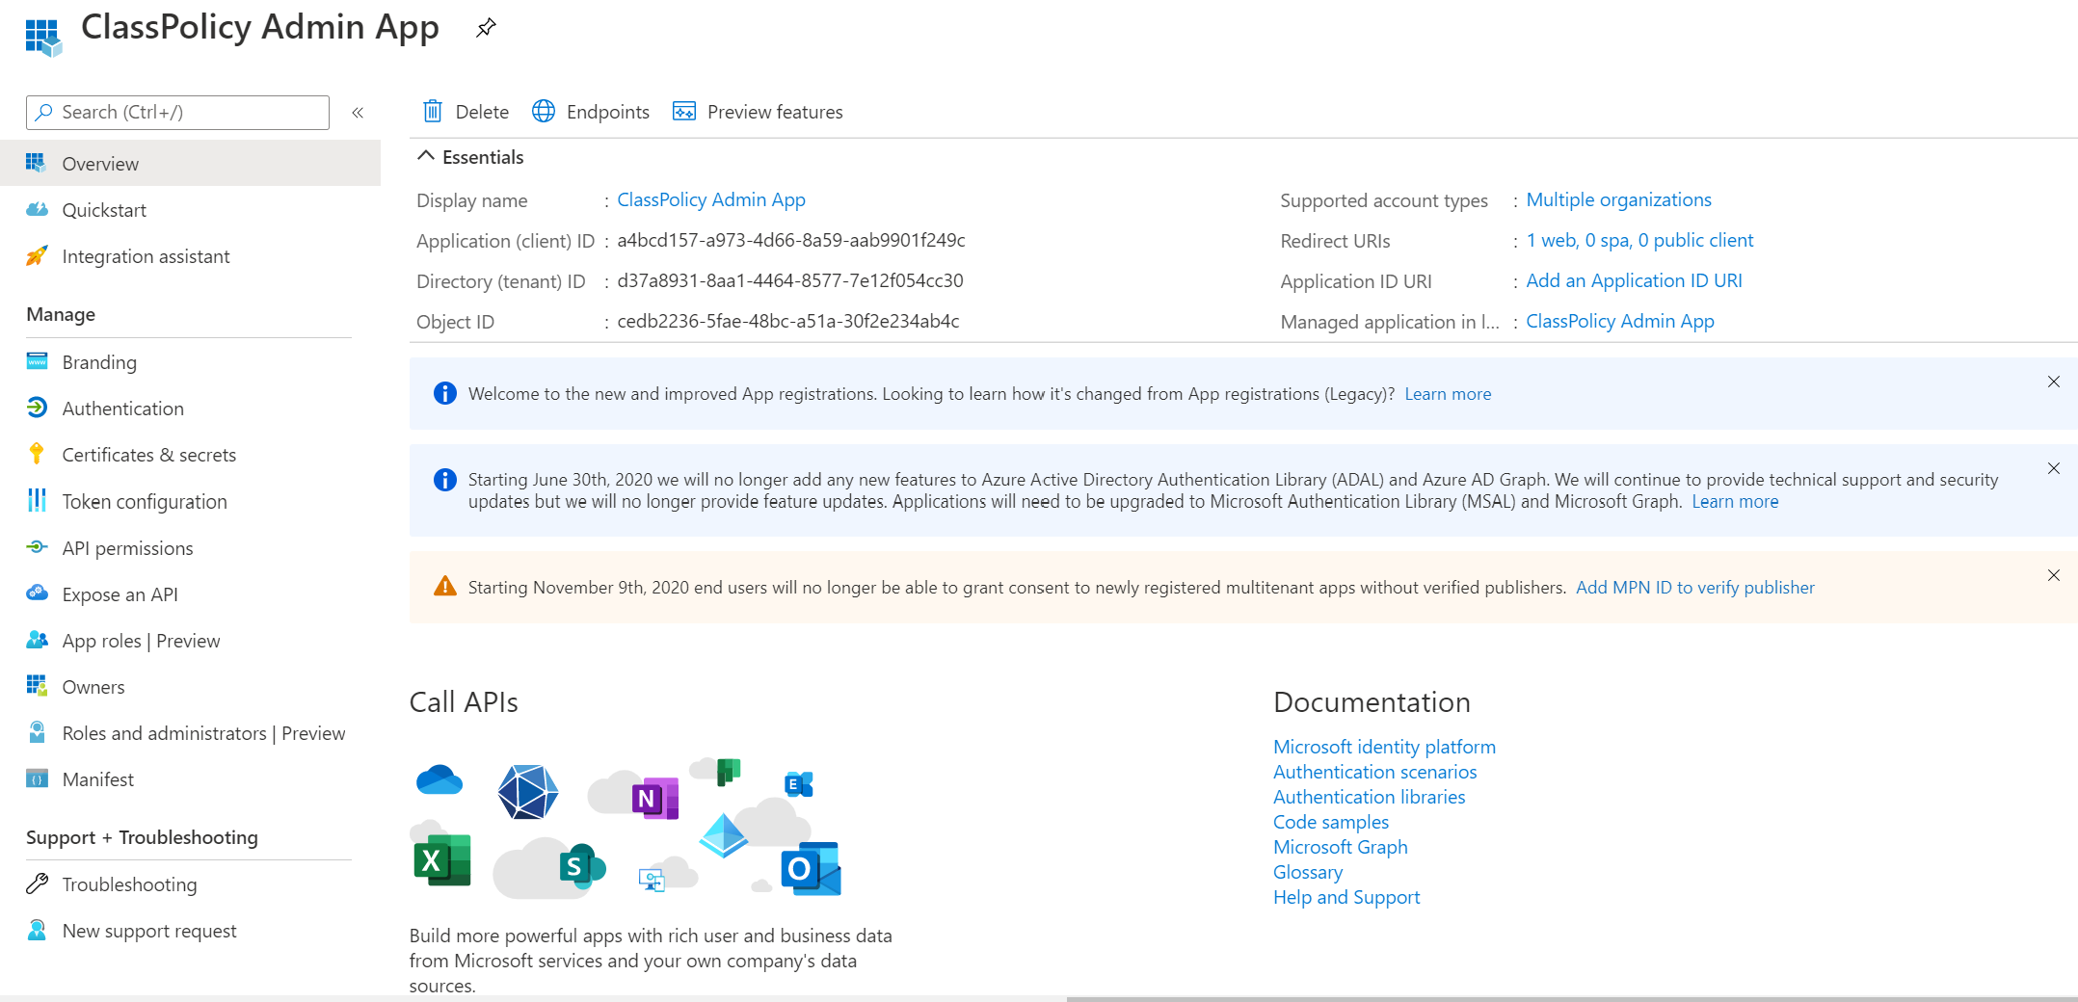
- Now it needs to generate a client secret. Go to Certificates & secrets and click New client secret. Copy the newly created client secret for the next steps.
- Go to API permissions and click “Grant admin consent for …”.

Configure ClassPolicy District Setting to enable Admin Azure AD Sign-in

- Login to the ClassPolicy Admin with your administrator credentials.

- From the left navigation bar, select “District” and then “Edit Admin AAD Groups”.

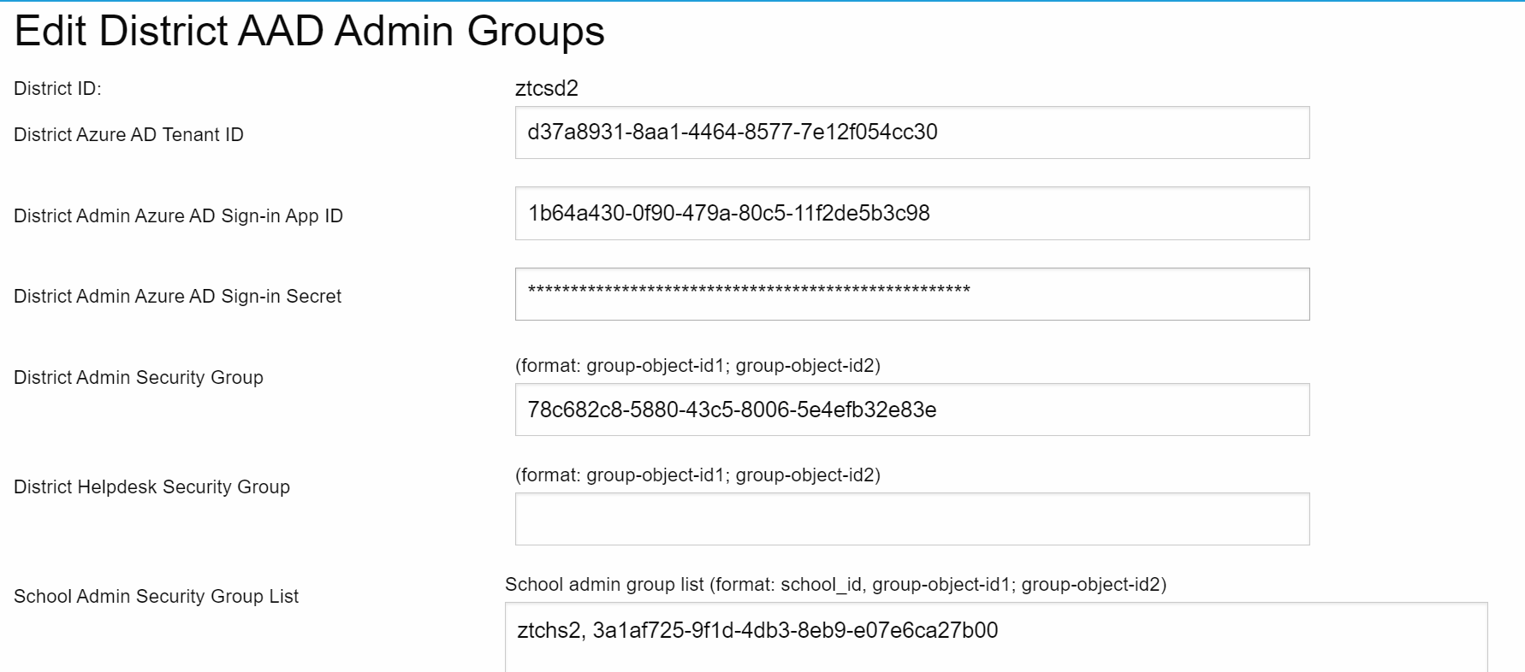
- Fill out the form with the below value.
  - Copy the Azure AD tenant ID from the Azure Management Portal and paste it into “District Azure AD Tenant ID” text box.
  - Copy the Application ID of “ClassPolicy Admin App” from the Azure Management Portal and paste it into the “District Admin Azure AD Sign-in App ID” text box.
  - Copy the client secret from the Azure Management Portal and paste into the “District Admin Azure AD Sign-in Secret”.
  - Copy district level admin security group’s object ID and paste into “District Admin Security Group” text box. In case you have multiple security groups, you can separate them with “;”.
  - If you have any helpdesk security group, copy & paste the helpdesk security group’s object ID into “District Helpdesk Security Group” text box.
  - If you have school level admin security group, then for each school, enter school ID, comma (“,”), and school admin security group’s object ID.

- Scroll down and click on the “Update” button to save changes.
- From ClassPolicy login page, turn on “AAD sign-in” checkbox to sign with AAD account.
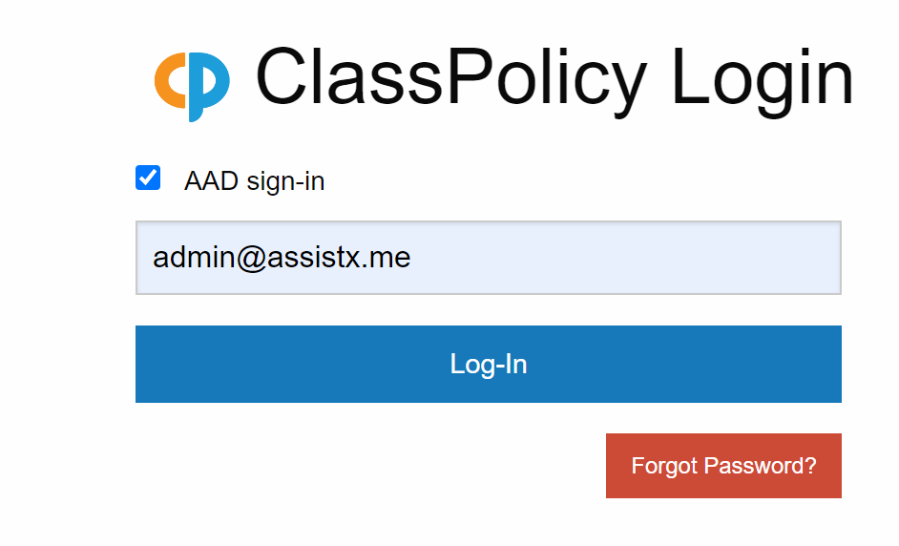
That completes the setup process to configure Azure AD sign-in for ClassPolicy school admins. If you have any issues, please contact us at support@assistx.me and we will be happy to assist you.

